Accessing Your Biometric Screening Results

Report Card: As a participant in today’s screening you have access to a health “Report Card”.
Your lab results should be posted to your Report Card within two weeks. Note – if you have participated in previous years, your Report Card will display the results of both years for comparison (last year’s lab results will appear alone until this year’s results are added).

- NEW participants will receive an e-mail from Mybiocheck (please be sure to check your junk/spam mail). You must use the e-mailed link to create your account.
RETURNING participants will need to go to the website direct to log in and retrieve your results: https://services.mybiocheck.com/MyBioCheckWebApp/Account/Login

- New users will create an account. Returning users will log in (please use “forgot password” link if you cannot recall your password).
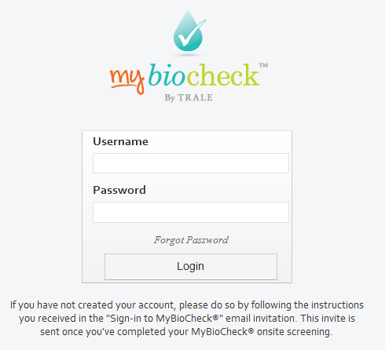
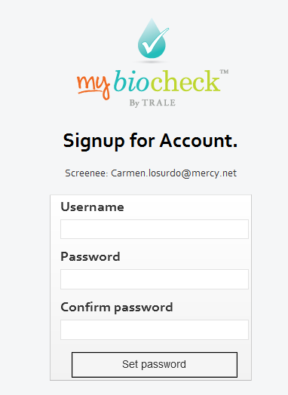

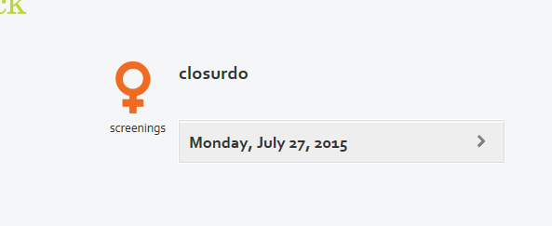
- Upon accessing your account, the Report Card date will be displayed. Simply click on the date to open/review your Report Card. Use your browsers’ print feature to print a copy (right click on the screen and select “print” from the menu).
Your name

Lab Results:
Lab results should appear on your Report Card within two weeks.
Participants with an active MyMercy account will also be able to access lab results (only) on MyMercy
within two weeks of the screening. Note – results do not always post at the same time and 14 days may expire before you can view all results.

If you have any issues/questions about your Report Card or lab results, please contact us at chwinfo@mercy.net

